CZ P-10S, a More Compact Version of the P-10 C
U.S.A. –-(AmmoLand.com)- I’ve said it before, and I’m going to say it again, CZ firearms can be addictive; getting one will more than likely lead to getting more, which can be detrimental to the health of your bank account. You should probably just stay away. It’ll start off with something small like a P10; next thing you know you’re getting SP01, then that escalates to a scorpion, then a Bren. Next thing you know you’re looking at a shadow, then a tactical sport orange, and at that point there’s no going back. You’re beyond help, there really should be a surgeon generals warning on the side of the box. If you’re still reading this, let’s talk about the CZ P10S. Where the masterminds at CZ took everything that was phenomenal about the P10C, (in my opinion one of the best service pistols currently available), and made it a little smaller than the mid size P10C.

CZ P-10S Subcompact Pistol
There are so many great aspects to the P10S, it’s kind of hard to figure out where to start, so let’s start with a trigger that is exceptional. I like everything about this trigger, I like the shape, it’s kind of a happy medium between a flat and traditional trigger; and feels very good. It’s also nice and smooth, much like the early 90’s rap group. The little bit of take up is very smooth, and a clean crisp break at just over 4 pounds. Then, the reset is short, tactile, and audible. It’s pretty much everything you could ever ask for in a trigger. Triggers that are this good aren’t usually seen in service pistols. I think this is probably the best factory trigger available. If it’s not the absolute best, it’s right at the top of the pack.
The grip is nothing short of amazing; it is instantly nice and slim, and it has a more vertical grip angel closer to that of a 1911 than the extreme angle of a Glock. I personally find this angle more pleasing and comfortable for my shooting. The trigger guard has a really nice deep undercut, and that coupled with the really high beavertail lets you grip the gun up nice and high. This minimizes muzzle flip and helps control recoil. The trigger guard is also nice and large; you could easily use it with gloves on. The grip is also reminiscent of the great grips on other CZ pistols like the CZ 75 line up.
The grip is the one area where I could see some people having an issue with the P10; as the texture is on the rough side. I personally love this and Glock guys spend a lot of money trying to make their grips have this much texture. But I can see people with really soft hands having issues with the P10 texture. There’s a nice little spot for your finger when its not on the trigger. It has slight little indentions around the magazine well should you ever need to rip out the magazine, and interchangeable palm swells to let you dial in your grip, just for you.
Now, one of the bigger changes from the P10C to the S model is that the grip got about a half an inch shorter, making it a little easier to conceal. I would say that my hands are about average size, and I can still get a full grip on the S model without any issues. One of the guys we shoot with has larger hands, and his pinky couldn’t quite get on the bottom of the grip, just to give you an idea about how it might fit a larger hand and grip. I think most people will be able to get a solid grip on the P10S, but if you do have really large hands, finding room for your pinky on the grip may be an issue.The smaller grip also brings the capacity down a bit to 12 plus one, from the 15 plus one of the C model.
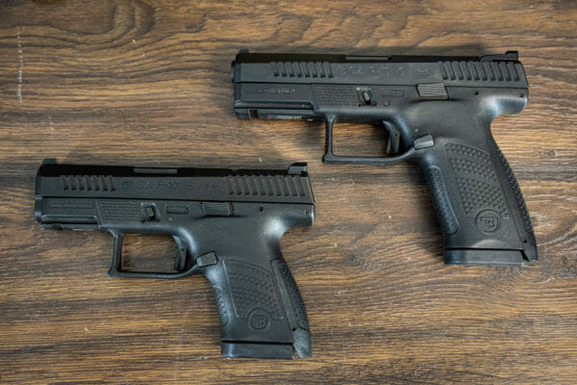
Size comparison between the P10S (left) and the P10C
Magazines are another change for the P10S. Some of the original CZp10C had really stiff magazine release buttons. To remedy this, CZ has changed the design from an ambidextrous out of the box design, to a release that is reversible for lefties. This new magazine release works extremely well, and I would say I like it a little better than my older models. However, sadly, the magazine had to change. You’ll notice two notches on the newer P10S, mag and only one on the Older P10C mag. Apparently, going forward, all new mags will be backwards compatible with the older models, but unfortunately the older mags wont work in the newer models.
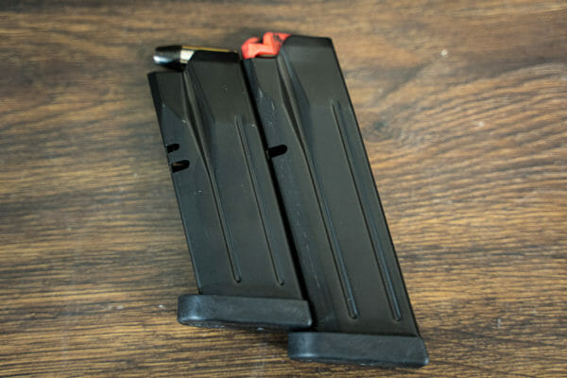
A new dual notch magazine (left) next to an older single notch
Another change worth noting, is internally on the S, they’ve gone to a dual recoil spring versus the single recoil spring in the C model. All of the internals are very robust, just like the original. The S also has a shorter slide than the C, again about a half an inch shorter. It still retains the great front and rear slide serrations and can even accept a flash light or other accessory, which some compacts cannot.
One thing I found very interesting, is because of some importation laws and the size of the P10S, this gun is now being made right here in Kansas City. I think that’s cool for a number of reasons. it’s awesome to have more super high quality offerings like this pistol being made in the states. Not having to import these pistols should make them more readily available, and allow CZ to import more of their harder to get offerings from the Czech republic. At least as I understand it.
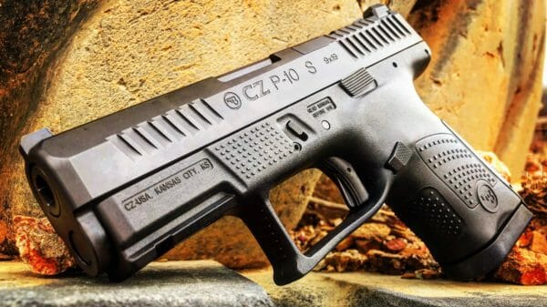
CZ P-10S
This is an optics ready pistol, and it will be cool to have a gun this compact with an RMR on it. In the manual it states that plates will be available for the Trijicon RMR and Leupold delta point. I know some people are going to complain that none come in the box; I actually like that and here’s why. When you get a gun that comes with like 4 plates, that adds a huge cost to the pistol and in all reality most people will only ever use one. By purchasing the plate afterwards keeps the cost of the pistol down and you only spend money on the plate you need. You won’t have a bunch of plates you’re not using lying around.
Shooting the P10S is great, much like the P10C it’s extremely accurate, soft recoiling, and just a general pleasure to shoot. The sights on this model have a serrated rear blade with a fiber optic and tritium front. This makes target acquisition quick and easy in any lighting condition. We ran 1000 rounds through this P10S without a single malfunction, and the reliability is exceptional, as I have come to expect from all my P10s. CZ went with the mindset of let’s make the gun a little smaller, but still very comfortable to shoot. I really like this because I’m personally not a fan of making a gun so small that its hard to shoot well. While there are smaller offerings, I think you’d be hard pressed to find a smaller, better shooting offering.
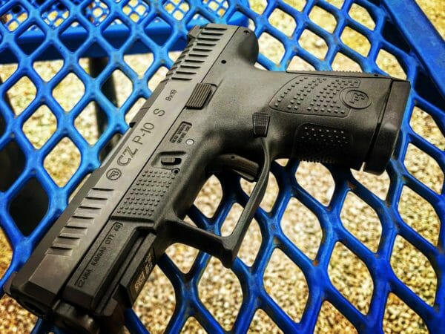
CZ P-10S
The P10 is my service pistol of choice. I know that people always ask do you like it better than this gun or that gun, and my answer is the P10 is always my first choice. Now, if you want to start adding some $1000+ guns to the comparison, I can find some that I like better. However, I wouldn’t consider guns in that price range a service pistol or a carry gun. I always tell people you can buy something else, put a lot of extra money in it, and try to get something close to the P10, or you can save yourself a lot of cash and time. Just buy a P10, they’re ready to go right out of the box, and now they’re available in mini and massive.

